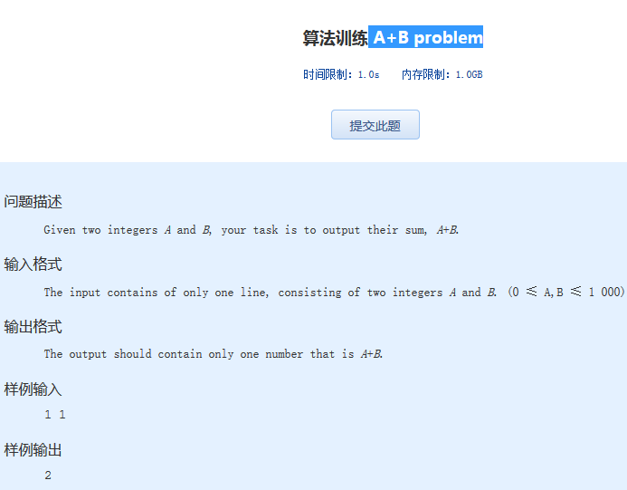  算法训练 A+B problem

时间限制：1.0s   内存限制：1.0GB

问题描述

　　Given two integers *A* and *B*, your task is to output their sum, *A*+*B*.

输入格式

　　The input contains of only one line, consisting of two integers *A* and *B*. (0 ≤ A,B ≤ 1 000)

输出格式

　　The output should contain only one number that is *A*+*B*.

样例输入

1 1

样例输出

2